2020

**Faulkton Area**

**Medical Center**

Community Health Needs Assessment

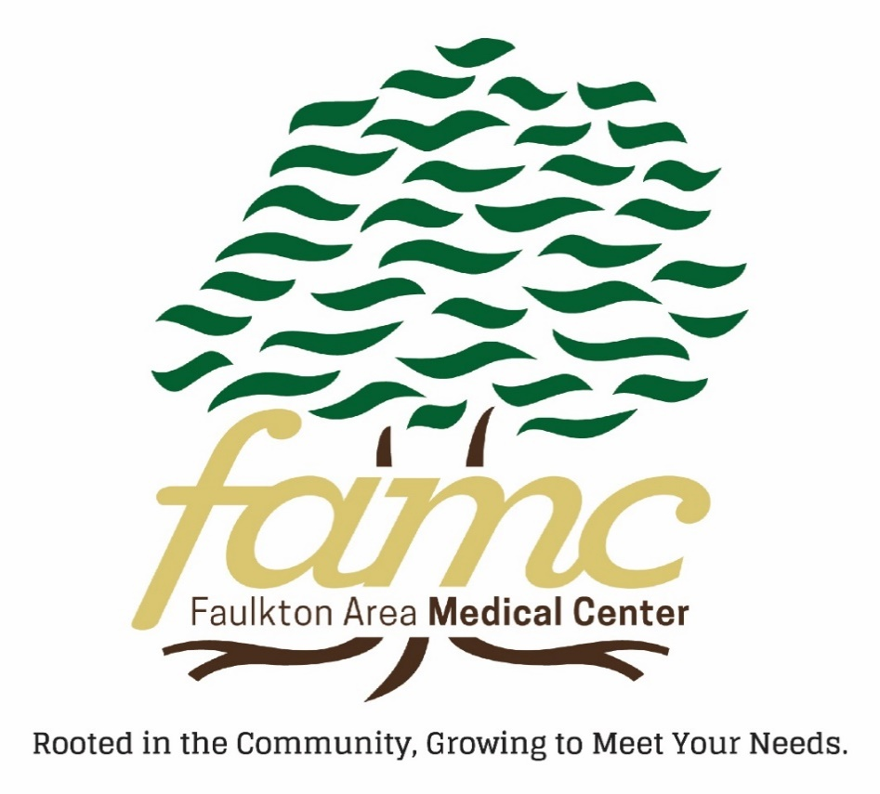

**EXECUTIVE SUMMARY**

Faulkton Area Medical Center is dedicated to best serving the medical needs of

the community with the resources available to the facility.

Mission Statement: The goal of the Faulkton Area Medical Center is to provide the appropriate level of healthcare on the continuum for clinic and outpatient/outreach care, emergency care, routine inpatient care, skilled swing-bed and intermediate swing-bed.

Faulkton Area Medical Center conducted a Community Health Needs Assessment (CHNA) for the residents of Faulkton and the communities included in Faulk County. The cities and towns that are in Faulk County are Chelsea, Cresbard, Faulkton, Miranda, Onaka, Orient, Rockham, Seneca, Wecota and Zell. The information and data obtained through the CHNA provides direction for prioritizing future strategies and collaboration to develop community driven goals.

The process to gather information included a community survey that was available online and inside the facility due to COVID restrictions. The surveys and data collection for the CHNA began in April 2020 and concluded May 2020.

The objectives were:

* To recognize health related concerns of community leaders and members.
* To classify common themes that can be prioritized for follow up.
* To develop strategic plans that can be committed to with action from Faulkton Area Medical Center and community collaboration.
* To devise appropriate skills and programs to improve the health and lives of our community and the members.

Anonymous surveys included designed questions with the participant choosing the appropriate response that described their age, gender, zip code, education, past general health history, race, home. Additional optional questions were as follows:

* What are the biggest health issues or concerns in your community?
* Do you have insurance?
* What do you think is the most pressing health care related need for you, your family or our community?
* What keeps people in our community from seeking medical attention?
* Where do you and your family get most of your health information?
* What health screenings or education services are needed in our community?
* In what ways do you think the hospital is serving the community well?
* In what ways could the hospital improve the way in which it serves the community?
* What services do you feel are needed in our community that currently do not exist?
* Do you see community members working together in collaboration to address community health needs?
* What is the number one thing the hospital could do to improve the health and quality of the community?

A total of 76 surveys were collected either electronically or manually.

**HISTORY**

Dr. Abbie Ann Jarvis, in 1898, was the first woman licensed to practice medicine in the state of South Dakota; as well as the first registered pharmacist in 1895, and had a pharmacy in Faulkton, SD. She moved to Faulkton during the winter of 1888, where her father was the local physician. She shared her father’s dream of providing health care to people and pursued that dream up to her death in May of 1931.

For approximately 34 years (1917 – 1951) patients were cared for at Providence Hospital, a frame building that was located on the same lot as the past, Faulkton Medical Clinic. The Faulk County Commissioners had unending efforts which resulted in a new brick structure in 1949 and opened to patients in 1951. Bond issues and Hill-Burton funds were the main channels for the secure financing and building of the hospital. In 1966, a large addition and remodeling project was started and completed in 1968, with the birth of the Faulk County Memorial Hospital (FCMH) being a modern 34-bed facility.

In 1983, Presentation Health System began leasing the hospital, and in 1984 the hospital entered a management agreement with the Presentation Health System, now known as Avera. This partnership continued until FCMH again became an independent facility in the fall of 1993. A new clinic, which was a separately funded and an incorporated facility, was attached to the south end of FCMH, and opened in May 1992.

In September 1993, FCMH was certified as the first Rural Primary Care Hospital in the nation. The hospital was licensed for twelve beds; six acute care and six swing beds. Beginning in late 1994, the hospital/clinic was managed by some private companies including Lutheran Health Systems of Fargo, ND followed by Tealwood Care Center of Mpls, MN. In 1998, the hospital/clinic’s classification again was changed. It was now determined to be a Critical Access Hospital and Rural Health Clinic. Once again, in August 2000, the facility became solely independent and continued to operate with the 12 licensed beds.

In 2004, Faulk County Memorial Hospital/Clinic became the only institution in South Dakota to receive funding through a combination of loans and grants to build a completely new facility. FCMH/C was one of only 32 facilities in the nation to obtain this highly sought after funding. In the same year, the Foundation Board was founded and launched a major fundraising campaign in April 2006, for the purpose of obtaining medical equipment, upgrade technology and establish an endowment for the benefit of the hospital and clinic.

In June 2007, the new facility was completed and officially named Faulkton Area Medical Center (FAMC). Located on the southwest edge of Faulkton, all related health facilities were physically joined together. FAMC is connected by a hallway to the Faulkton Healthcare Center (nursing home) and The Meadows (assisted living). The nursing home and assisted living facilities are owned and operated by a private corporation.

In November 2017, a new outpatient/infusion center was completed and opened after months of construction. This has been in the planning and implementing stages since the 2013 CHNA survey and results. This provides patients who require infusions to remain close to their residence and reduce the travel time and expenses to the patient and their family. FAMC continues to be governed by an independent, local board of directors.

**DEMOGRAPHICS - COMMUNITY SERVED**

[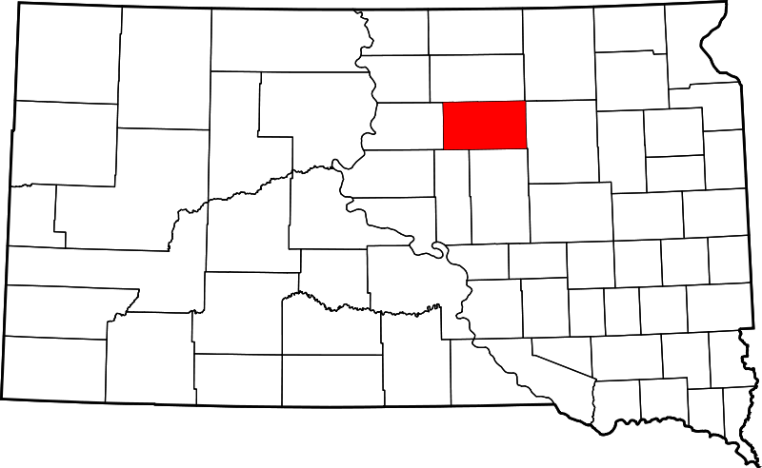](http://upload.wikimedia.org/wikipedia/commons/2/23/Map_of_South_Dakota_highlighting_Faulk_County.svg)

Faulkton Area Medical Center defines its primary service area as Faulk County. According to the 2017 census, there were 2,330 people residing in Faulk County.

This is a decline of 1.4% from the 2010 census population of 2,364. The Faulk County population density is 2.35 people/sq. mile; which is much lower than the state average of 10.7 and the national average of 87.4 people/sq. mile. The prevailing race is white, which represents 97.7% of the total population. The average high school graduate education level is higher than the state and national average.

Faulkton is the largest city and the county seat for Faulk County. The other towns/communities that are included in Faulk County are as follows:

Chelsea: Pop. 27

Cresbard: Pop. 104

Faulkton: Pop. 736

Miranda: Pop. 12

Norbeck: Pop. 5

Onaka: Pop. 15

Orient: Pop. 63

Rockham: Pop. 33

Seneca: Pop. 38

Wecota: Pop. 14

Zell: Pop. 50

There are also four Hutterite colonies that are within a 25 mile radius of Faulkton, which many chose Faulkton Area Medical Center to provide services to their families and members. They are Thunderbird, Evergreen, Brentwood and Blumengard colonies.

84% - 90% of Faulkton Area Medical Center admissions are residents from Faulk County; and hospital discharge totals have ranged between 315 – 370 annually over the past three years.

<https://www.census.gov/acs/www/data/data-tables-and-tools/data-profiles/>

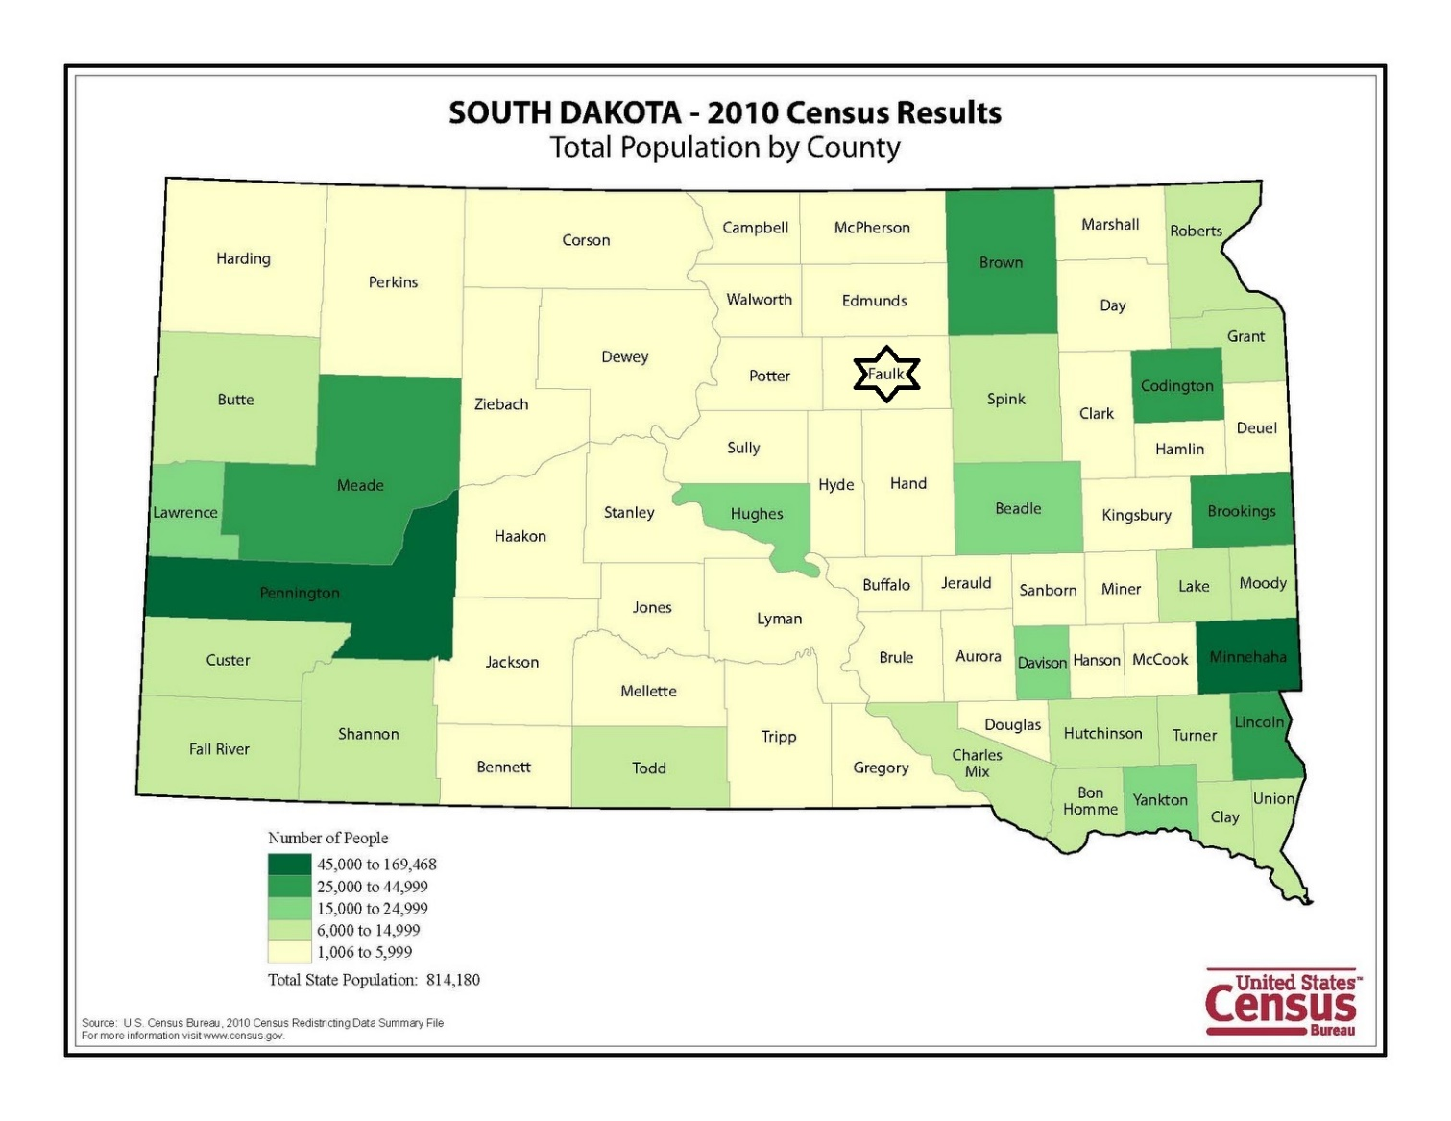

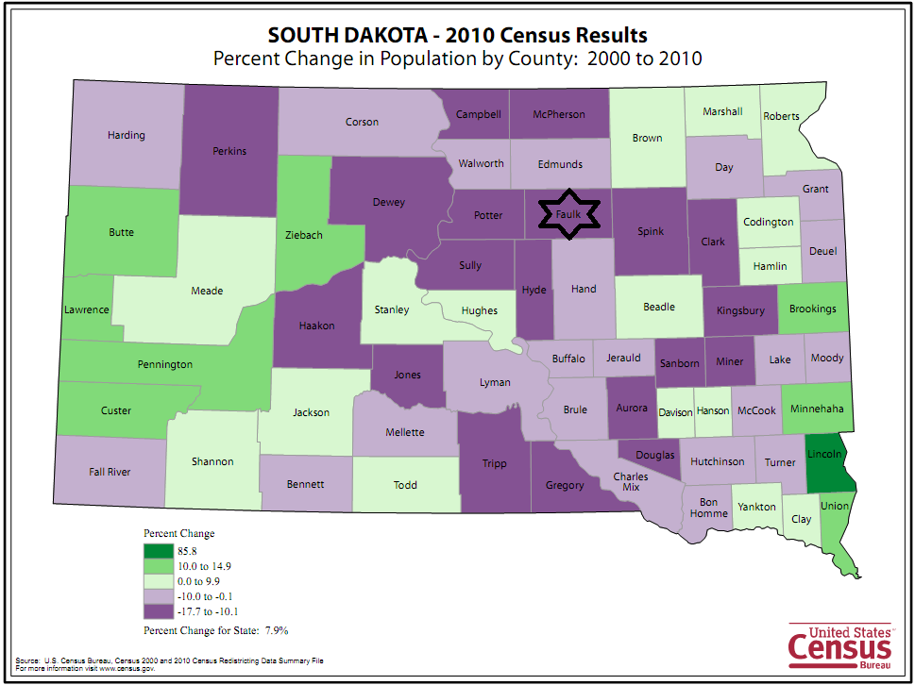

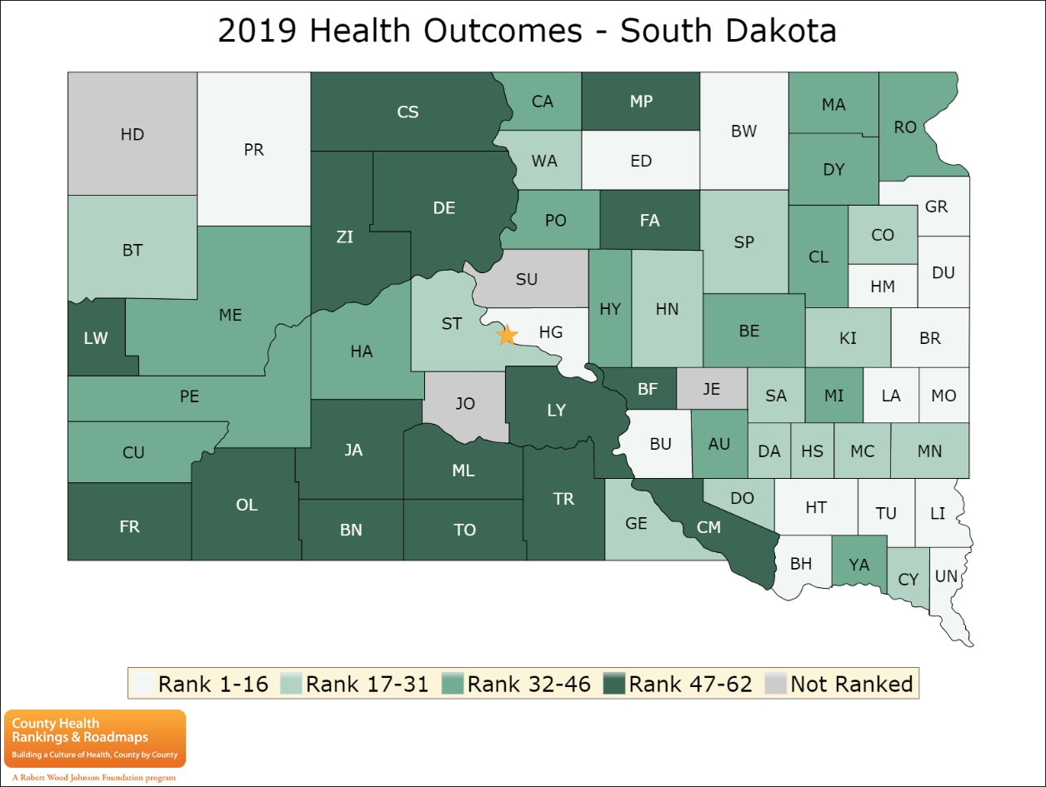**HEALTH OUTCOMES & FACTORS**

The maps on this page display South Dakota’s counties (66 total, 4 of which are not ranked) divided into groups by health rank. They help locate the healthiest and least healthy counties in the state. The lighter colors indicate better performance in the respective summary rankings. The green map shows the distribution of summary health outcomes. The blue displays the distribution of the summary rank for health factors.

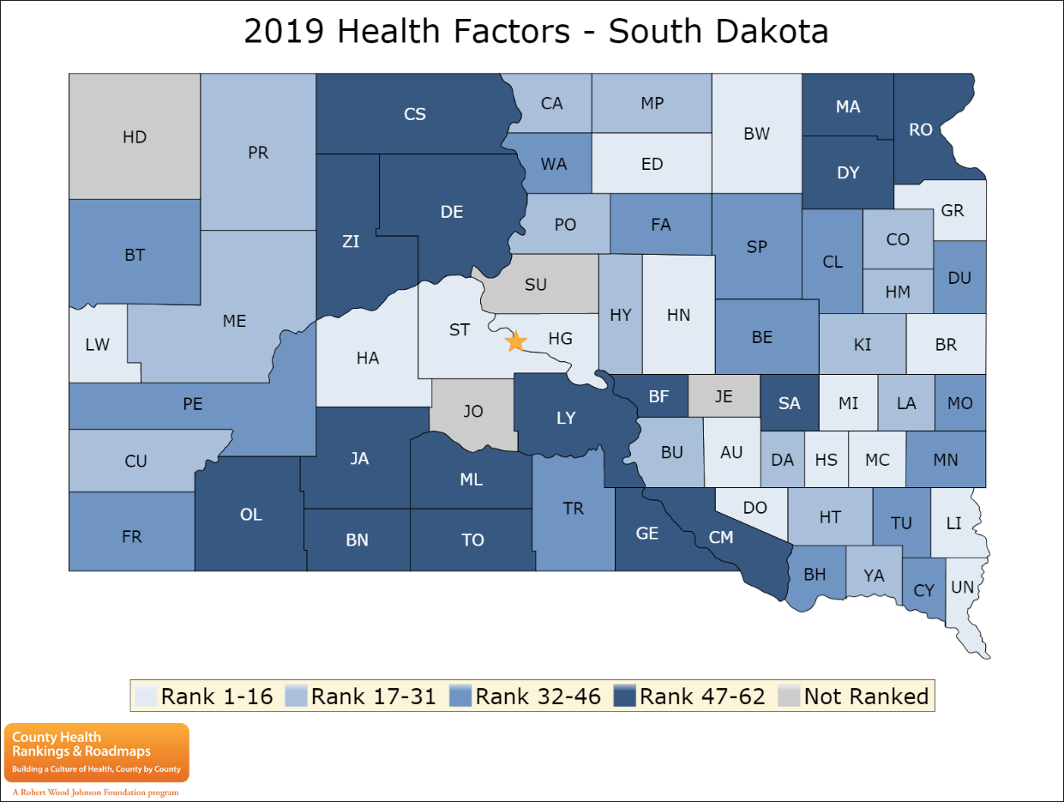**Faulk County rankings: #48 for the Health Outcomes: How healthy the county is #36 for the Health Factors: What influences the health of the county** [www.countyhealthrankings.org/south-dakota](http://www.countyhealthrankings.org/south-dakota)

**CURRENT SERVICES & COLLABORATIONS**

The following services are available at Faulkton Area Medical Center, either as Inpatient, Outpatient or Outreach Clinics. The Hospital and Emergency Room is open 24/7. The Clinic, Outpatient Center and Therapy department hours are Monday through Friday 8am – 5pm.

Allergy Shots ABI/Spirometry

Bone Density Cardiology/Cardiac Rehab

Chiropractor Diabetic Foot Care

Dietician EGD/Colonoscopy

Family/General Practice Hearing Aid Clinic

Health/Fitness Education Infectious Disease

Joint Injections Lab/Phlebotomy Services

Mammography Mental Health

MRI Nutrition Specialist

Outpatient IV Therapy Rehabilitation – PT/OT

Sleep Studies Stress Testing

Speech Therapy Telemedicine

Ultrasound/Echo Urology

X-ray/CT Scans

Community Partnerships & Collaboration Efforts that are in place and continue to strengthen the community awareness to improve the health and quality of life in Faulk County and surrounding areas:

- Faulkton Area School District

- Out of School Program

- Dacotah Bank

- Faulk County Cancer Support Group

- Faulk County Senior Center

- Faulk County Library

- Faulkton Fire Dep’t.

- Faulk County Ambulance

- Faulkton Healthcare Center – Nursing Home

- The Meadows – Assisted Living Facility

- Business & Professional Association

- Faulk County Record

- Faulk County Community Health Office

- Faulkton Area Economic Development

- Faulk Co. Jail

- Faulkton City Pool

**DATA ASSESSMENT ANALYSIS**

**# Of Faulk County Residents**

**that participated**

**in the survey**

Faulkton is the largest city of Faulk County and is the county seat.

There were a total of 76 surveys collected; 66 were from zip codes that are located within Faulk County. The survey was accessible electronically or paper surveys. Out of those two options, 72 were submitted electronically on-line and 4 completed a paper version. As noted above, the largest percentage of surveys were completed by Faulkton city residents. Below are actual phrases and statements from the CHNA surveys listed in random order and importance.

|  |  |  |
| --- | --- | --- |
| Answer Choices | Responses | |
| Yes | 98.68% | 75 |
| No | 1.32% | 1 |

**Why?** Part of HealthShare group - not traditional insurance.

|  |  |  |
| --- | --- | --- |
| Answer Choices | Responses | |
| 6 months | 9.21% | 7 |
| 12 months | 11.84% | 9 |
| 2 years | 11.84% | 9 |
| 5 years | 14.47% | 11 |
| 10+ years | 31.58% | 27 |
| Never | 17.11% | 13 |

|  |  |  |
| --- | --- | --- |
| Answer Choices | Responses | |
| Yes | 85.53% | 65 |
| No | 14.47% | 11 |

**What are the biggest health issues or concerns in your community?**

* Keeping healthcare close to home, elderly home health care, COVID, after hours care, emergency care, general health, diabetes, obesity, allergies, exercise, eating healthy, cancer care, young adult health, vaping, drinking, general safety, influenza, cost, education, orthopedics, surgical procedures, ventilators, accessibility, heart disease, availability, road safety, high level care

**What do you think is the most pressing health care related need for you, your family or our community?**

* More outreach clinics, primary care visits, home health, cost, emergency care, ambulance, quality doctors availability, COVID, cancer, education, nurse at school, community safety, health and wellness, dermatology, more surgical procedures, pulmonologist, mental health, neurologist, chronic disease management, neonatal, heart health, pediatric care, diabetes, intubation in an emergency, insurance, education

**What keeps people in our community from seeking medical attention?**

* Distance and time of travel, cost, lack of insurance, becoming exposed to other illnesses, availability/lack of motivation to go to appointments, privacy/doctor-patient relationship, services not available locally

**Where do you and your family get most of your health information?**

* FAMC facility, other medical facilities, internet, news, insurance companies, newspaper, Facebook, CDC, books, drug store

**What health screenings or education services are needed in our community?**

* Community Health, yearly screens, skin cancer, cancer, mental health/cognitive, eyes/vision, cardiac, pediatrics, diabetes, prostrate, mammograms, First Aid/CPR, COVID, critical care, neonatal, elderly, drugs

**In what ways do you think the hospital is serving the community well?**

* Doing well, options/variety, quality, staff, accessibility, availability, education, quality of facility, community partnership, primary care, hospital, emergency, COVID proactive

**In what ways could the hospital improve the way in which it serves the community?**

* Billing, cost, urgent care, more outreach, higher level care, pediatrics, primary care providers, communication/relationships, more testing, community partners, provide home health, convenience, education, clinic exams, wellness, mental health, vision

**What services do you feel are needed in our community that currently do not exist?**

* Home health/hospice, orthopedics, higher level care, cancer, walking path, mental health, restaurants, urgent care (weekend/evening hours), community health nurse, neonatal/ OB-GYN, community garden, water therapy, mammograms, radiology, podiatrist, developmental disabilities services, movie rentals, clinical exams, body shop, workout, immunologist, neurology, allergies, colonoscopies, senior day discount for medical procedures, assistance for low-income, COVID, outreach

**Do you see other community members working together in collaboration to address community health needs?**

* Generally works together, wellness/fitness/health programs, hospital/foundation/FAMC, blood drives, social media, community board meetings, Community Health Nurse, Quality of Life Committee

**What is the number one thing the hospital could do to improve the health and quality of life of the community?**

* Health and wellness classes, hospice and home health, staffing, education, screenings, higher level care, lower costs, billing, fitness center, reach out and check on patients, vision, quality services, recruitment fund for staff, cancer care, mental health, school nurse, MRI, outreach, urgent care, increase senior care

**Other comments:**

Uninterested because of cost/time of service/lack of medicine coming out, better communication, providers/facility doing a great job, lack of quality of food, increase chemotherapy patients locally, recruitment and/or education assistance program available, increase wages for cooks and CNAs

This chart identifies the **number** of people who selected the various healthcare procedures/exams/referrals in the past 12 months.

Refer to page 8 for a complete listing of services that are available through Faulkton Area Medical Center.

Pt. Services provided by FAMC providers

Pt. Services provided by Outreach Clinics at FAMC

Pt. Referrals made by FAMC providers

**COMMUNITY HEALTH NEEDS IDENTIFIED**

Faulkton Area Medical Center has many of the listed programs and services in place to help meet many of the suggestions on the CHNA surveys. This assessment was very useful and helpful in understanding the community and surrounding areas perceptions of FAMC and healthcare. It assisted our focus groups and committee to determine and support the needs identified by the community of Faulk County and surrounding area.

The leading concerns and needs that were identified and prioritized from the data collected in the surveys are:

1. Home Health Care/Hospice
2. Cost/Billing
3. Telehealth/ Outreach services
4. Education

**IMPLEMENTATION STRATEGY**

Our implementation strategy will focus on all aspects of the highest priority of needs that best accommodate our community.

1. Visiting Nurse program through the Rural Health Clinic. FAMC has researched and is attempting to implement a new program that is like Home Health to meet the community’s need for Home Health/Hospice services. The Visiting Nurse Program is through the Rural Health clinic and will consist of a nurse coming to a place of residence to provide skilled nursing visits for our patients. Due to the COVID-19 pandemic, this program has been put on hold at this time. There will be more information provided to the community as it becomes available.
2. Patients are encouraged to apply for Financial Assistance if desired. A brief application is required, with a copy of the guarantor’s most recent IRS tax return and evidence of the most recent three months’ income. The application form is available at Patient Registration, Clinic Registration, the ER Waiting Room, and each of the Emergency rooms. The form is also available on the FAMC website, and by mail if requested by contacting the Billing Office or Administration. Administration will calculate the discount and inform the requesting party within 30 days of receipt of the application. The calculated discount will remain in effect until April 1, and new application must be made for charges incurred beginning every April 1.
3. Telemedicine Program. FAMC is in partnership with Avera Health System to provide virtual Doctor visits to patients without the need to travel. Through this partnership, FAMC can connect with your Avera provider virtually and save travel, time, and expense.
4. It was identified that FAMC could improve education in the community and school on various health topics and services provided at FAMC.  
   In the fall of 2020, FAMC signed an agreement to provide Health Services to the school. Within this contract, health education is a key component. We provide education on the following topics to the students: infection control/handwashing, nutrition, male and female growth and development, oral health, safety and injury prevention, suicide prevention, tobacco and substance abuse. Each year, the sophomore class is provided CPR certification. We also provide education to the school staff that include, infection control/handwashing, worksite wellness, and education specific to disease processes that they work with in the school and any other topic that they request. Within the contract, FAMC also provides a variety of health screenings and vaccinations including, athletic physicals, scoliosis screening, hearing screenings, dental exam, vision exam, height/weight assessments, kindergarten and 5th grade vaccinations, flu vaccination, and meningococcal vaccinations. Although this agreement was mentioned in the FASD Board Meeting Minutes, FAMC plans to write an article in the Faulk County Record and send out a district wide email to educate the community on this new agreement with the school.  
   FAMC also works with the Faulkton Area Out of School Program to provide health education. In 2020, we provided education in the following areas: infection control/handwashing; nutrition; sun safety, manners/respect; eye health; oral health; importance of physical activity, fire prevention, and water safety.   
   In the area of community education, FAMC places a weekly ad with a “Medical Minute” article in the Faulk County Record. The Medical Minute is written by a member of the medical staff and addresses a pertinent health topic for that week. FAMC also has an active presence on social media Facebook and Instagram. There has been discussion about adding a blog/article area to our website, but we do not have adequate staffing to implement this at the current time. Instead, we plan to send out a bi-annual or quarterly health education newsletter to the patrons in our service area. The newsletter will be edited by the Foundation Coordinator and Education Chair with content provided by the Medical Staff and Department Managers.   
   In 2019/2020 the Therapy and Nutrition Departments also provided Chair Exercises, Walk with Ease, and Fit and Strong – all community fitness programs as well as a monthly health education series that was attended by approximately 8-10 people each month. These programs were put on pause for a short time due to the COVID-19 pandemic. The fitness classes have since resumed in an on-line format, but the community education series has not. We will re-evaluate re-implementing this in 2021 and if it is not feasible, we will include this information in the upcoming Community Newsletter.   
   In the area of patient education, FAMC has recently created a position within the clinic titled “Community Care Nurse”. This position manages the Chronic Care Management Program and Target: BP™ Program at FAMC. Patients with two or more chronic conditions are enrolled into the Chronic Care Management Program at the discretion of their medical provider. The services available through our Chronic Care Management program include: 1) Help in managing ongoing health conditions, regular check-in’s, help in making appointments for preventive care, and helping patients understand and take their medications, 2) Helping patients have access to their provider or care team 24-hours-a-day, 7-days-a-week, including by telephone, email, and through your electronic health record, 3)  Working with patients to make a plan for how to best care for their health issues, 4) Helping patients work with and coordinate care across different providers and settings, including specialists or other providers, hospitals, and emergency department. Target: BP™ is a national initiative formed by the American Heart Association (AHA) and the American Medical Association (AMA) in response to the high prevalence of uncontrolled blood pressure (BP). Target: BP helps health care organizations and care teams, at no cost, improve BP control rates through an evidence-based quality improvement program and recognizes organizations committed to improving BP control. These are two new programs that will be promoted in the FAMC Community Newsletter.  
   On the Critical Access Hospital side, FAMC places discharge education directly into the patient’s chart. This information is printed and given to the patients upon discharge. In many instances, this education is individualized to fit the patient’s needs.

In 2021, the Utilization Review Department will be implementing a Transitional Care Program. Transitional care management taking responsibility for the care of patients following discharge from an inpatient hospital setting. This program is designed to decrease avoidable hospital readmissions and assist patients in organizing their care following discharge. Again, this new program will be highlighted in the FAMC Community Newsletter.

As the needs of our community change, we will review our methods of education, programs and services to raise awareness and fulfill the needs of the community.

**BOARD APPROVAL**

This Community Needs Health Assessment, a requirement of the IRS, has been conducted to determine and assess needs through data collection and collaboration with community leaders and members, along with the mission statement of Faulkton Area Medical Center to improve the health of people in Faulk County and surrounding areas. This process provides direction for prioritizing our future strategies in developing community driven goals.

This report was prepared for the calendar year dated January – December 2020.

Faulkton Area Medical Center Governing Board Approval:

Heather Bode, CEO Date

Susan Miller, CFO Date

Kelly Ortmeier, CHNA Coordinator Date

Verne Hansen, Board President Date